

**CAPSTONE PROJECT REPORT**

**Report 5 – Software Test Documentation**

# **II. Project Management Plan**

## **1. Overall Description**

### **1.1 Test Model**

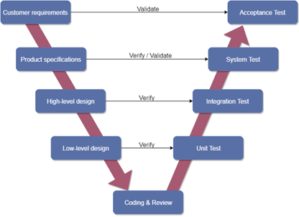

Overall, we choose V-Model to implement the testing process. With V-Model, software development is separated into two appropriate phase’s groups: development and testing. In this model, the verification and validation will be done side by side. It emphasizes the strict process flow to develop a quality product. The errors occurring in any phase will be corrected in that phase. Proactive defect tracking defects, which are found at early stages even, may be in the development phase before application being tested.

### **1.2 Testing Levels**

### **1.3 Testing Types**

The test team has to test the following type on Google Chrome browser and :

* GUI test
* Function test
* Acceptance test
* Unit test

|  |  |  |  |
| --- | --- | --- | --- |
| **Type of test** | **Stage of test** | | |
| **Integration test** | **System test** | **Acceptance test** |
| Unit test | x | x |  |
| GUI test |  | x | x |
| Function test | x | x | x |
| Acceptance test |  | x | x |

Table 5.1 – Test type

## **2. Test Plan**

### **2.1 Test Stages**

In this project, there are 3 phases in the testing process: Integration testing, System testing and Acceptance testing.

|  |  |  |
| --- | --- | --- |
| No. | Test Stages | Description |
| 1 | Integration testing | Integration testing allows individuals the opportunity to combine all of the units within a program and test them as a group. This testing level is designed to find interface defects between the modules/functions. This is particularly beneficial because it determines how efficiently the units are running together. |
| 2 | System testing | System testing is the first level in which the complete application is tested as a whole. The goal at this level is to evaluate whether the system has complied with all of the outlined requirements and to see that it meets Quality Standards. |
| 3 | Acceptance testing | Acceptance testing (or User Acceptance Testing), is conducted to determine whether the system is ready for release. During this phase, the tester and some alpha test users will test the system to find out whether the application meets their business’ needs. |

Table 5.2 – Testing stages

### **2.2 Resources**

#### ***a. Human Resources***

|  |  |  |
| --- | --- | --- |
| **Worker/Doer** | **Role** | **Specific Responsibilities/Comments** |
|  |  |  |
|  |  |  |

#### 

#### ***b. Environment***

|  |  |  |  |
| --- | --- | --- | --- |
| **Purpose** | **Tool** | **Provider** | **Version** |
|  |  |  |  |
|  |  |  |  |

### **2.3 Test Milestones**

|  |  |  |  |
| --- | --- | --- | --- |
| **Milestone Task** | **Effort (md)** | **Start Date** | **End Date** |
|  |  |  |  |
|  |  |  |  |

### **2.4 Deliverables**

|  |  |  |
| --- | --- | --- |
| **No** | **Deliverables** | **Due Date** |
| 1 |  |  |
| 2 |  |  |

## **3. Test Cases**

Test cases have been managed on the [Test Case Sheet](https://drive.google.com/file/d/1X_9vBe1qs53Yzc2_xQe72vfOo2-Vw9uE/view?usp=sharing). These are some example images about the Test cases below:

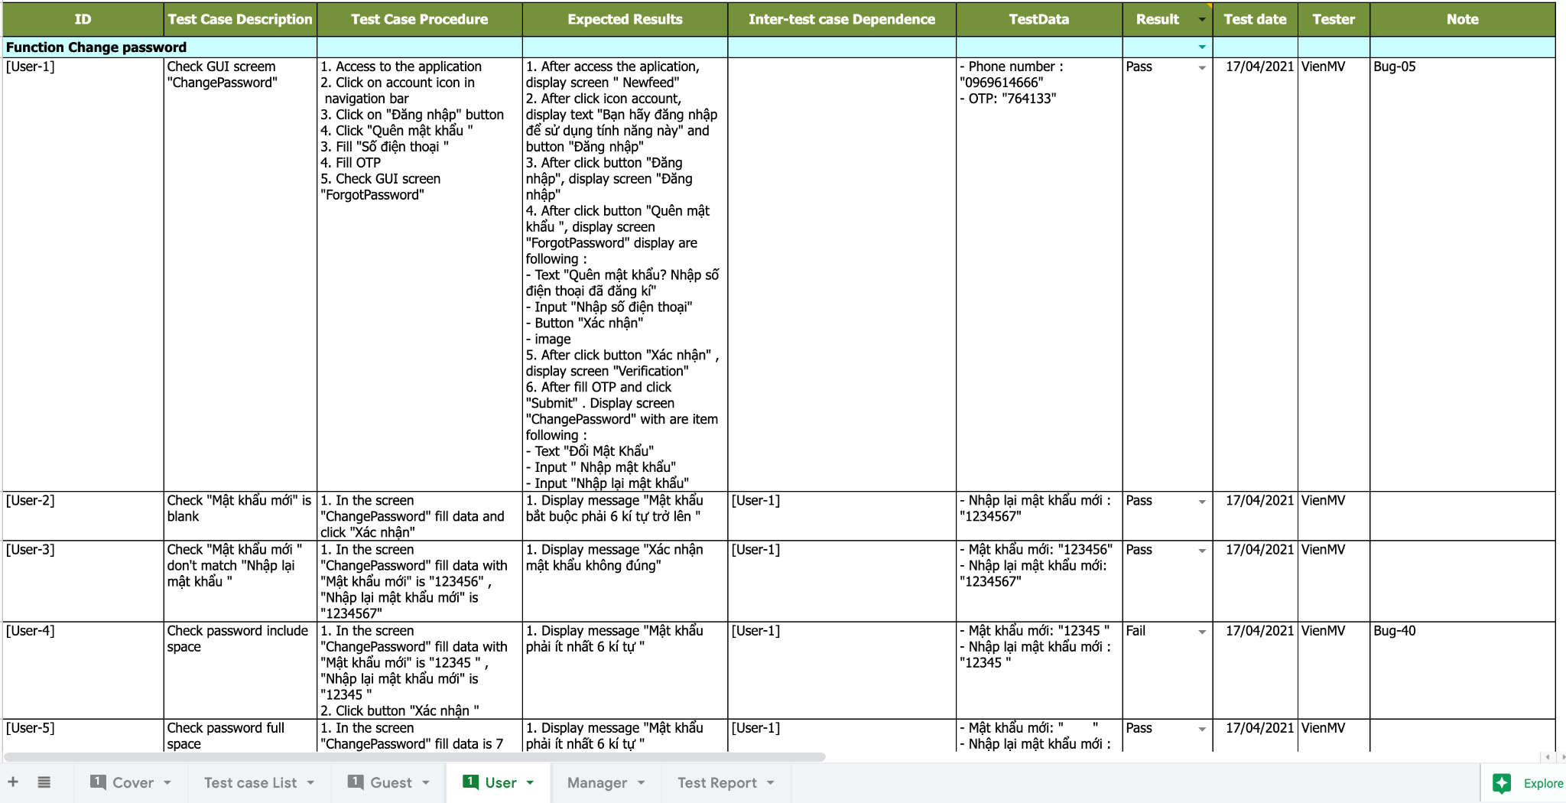

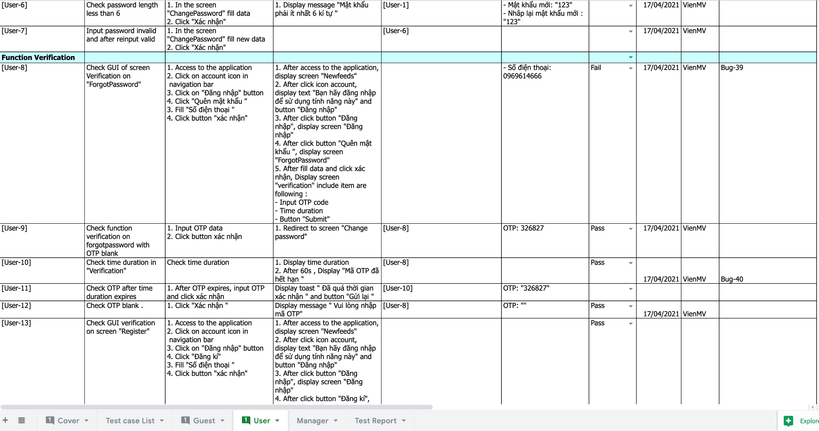

## **4. Test Reports**

* Test report has been manage on the [Test report sheet](https://docs.google.com/spreadsheets/d/1X_9vBe1qs53Yzc2_xQe72vfOo2-Vw9uE/edit#gid=1789090907)